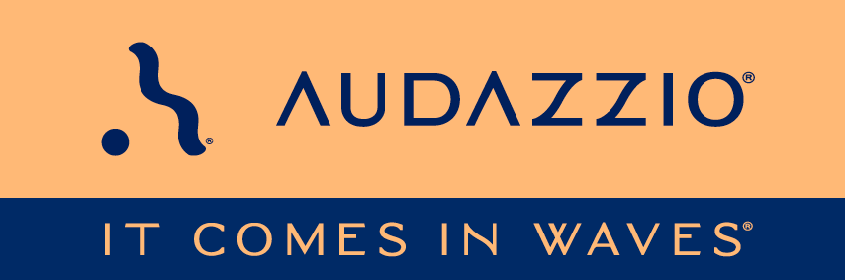

FOR IMMEDIATE RELEASE

**Audazzio® promotes Michele Klumb to Chief Operating Officer**

*Seasoned entrepreneur, engineer, and marketer continues to strategize for Audazzio*

San Antonio, TX, (January 21, 2025): Audazzio®, an innovative software startup and finalist in Comcast NBCUniversal’s SportsTech Accelerator inaugural program, is continuing to expand and enhance its executive leadership team with the promotion of Michele Klumb. A seasoned entrepreneur, Klumb brings extensive expertise that will continue to enhance the team's performance.

Klumb, who has been with Audazzio since 2020, has been promoted from Vice President of Marketing to Chief Operating Officer by the Audazzio Board of Directors. The announcement was made by Roy Terracina, Chief Executive Officer and Chairman of the Board. Klumb, an out-of-the-box thinker, possesses a unique educational background that includes a Bachelor of Science in Mechanical Engineering (BSME) and a Master of Business Administration (MBA). With over 20 years of diverse experience, her skill set spans design—where she currently holds five patents—sales, marketing, advertising, business development, and operations.

Previously, Klumb provided sales, marketing, business development, and engineering project management at Audazzio, making her transition to Chief Operating Officer seamless. She now officially oversees the day-to-day operations of the fast-growing and disruptive solutions development company. Klumb and her Audazzio team made great strides in 2024. She is now challenged to push the Audazzio proprietary technologies across multiple finish lines in the broadcast, sports, retail, and live events markets.

Klumb remarked, “When the Audazzio technology was pitched to me in late 2019, I knew I wanted to be part of the company. Audazzio has a unique ability to engage audiences at the exact moments their interests are piqued. We have a strong core team, a truly frictionless product, and a company with incredible growth potential.”

Terracina noted, “In early 2024, Michele took the initiative to address areas that needed attention. Although I had previously recognized her behind-the-scenes contributions, I was genuinely impressed by her unwavering commitment to Audazzio. Her promotion to COO is well-deserved; she is an excellent team member who keeps us all moving forward.”

In today’s fast-paced world, timing is everything. The Audazzio technology enables you to capitalize on moments when audience interests are heightened by seamlessly delivering second-screen content in those precise instances. People want immediate access to information with minimal friction, and Audazzio provides that in under a second—connecting audiences to what they desire.

“I refer to Audazzio as the ‘magic wand’ for connecting with audiences. I am constantly researching players, actors, and locations during an event. With Audazzio, I can access all this information, and more, without lifting a finger or missing any action happening in front of me. The possibilities are endless with Audazzio,” says Klumb.

The Audazzio Live QR™ solution integrates micro-signaling into any audio stream, allowing content to be delivered seamlessly to phones or tablets, fully synchronized with the event. This opens up a wide range of applications for broadcasters, sports rights holders, venues, sponsors, betting operators, and more. Audazzio equips clients with tools to deliver targeted messaging directly to audiences in real time, whether they are at home, a retail location, a stadium or arena.

For more information on Audazzio, please visit [www.audazzio.com](http://www.audazzio.com).

For a video primer on Live QR technology from Audazzio, visit [www.audazzio.com/explainer](http://www.audazzio.com/explainer).

Photo file 1: MicheleKlumb.JPG

Photo caption 1: Michele Klumb, Audazzio Chief Operating Officer

FOR MORE INFORMATION PLEASE CONTACT:

Audazzio | 855.697.6627 | [info@audazzio.com](mailto:info@audazzio.com)

**About Audazzio®**

Audazzio® is an innovative media company that was a recent participant in the Comcast NBCUniversal’s SportsTech Accelerator program. Based in San Antonio, TX, Audazzio delivers groundbreaking technologies that enable broadcasters and event producers to seamlessly change the content on a fan’s mobile device, in real time, fully coordinated with their broadcast or event. In much the same way that a QR code graphic provides a unique digital fingerprint for a variety of uses, the Live QR™ algorithm from Audazzio embeds micro-signaling into an audio stream to seamlessly deliver content on a phone or tablet. By leveraging Live QR™ technology, marketers have access to an entirely new channel to reach consumers’ mobile devices, at critical moments in an event or broadcast, when they crave more information and storytelling. Audazzio can deliver any web page, at any time, to any device within range of the Live QR signaling, opening the door to a whole new world of applications for savvy broadcasters, sponsors and beyond.